**Sort List**

<https://leetcode.com/problems/sort-list/>

Given the head of a linked list, return *the list after sorting it in****ascending order***.

**Example 1:**

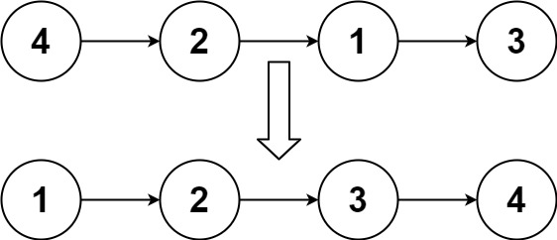

**Input:** head = [4,2,1,3]

**Output:** [1,2,3,4]

**Example 2:**

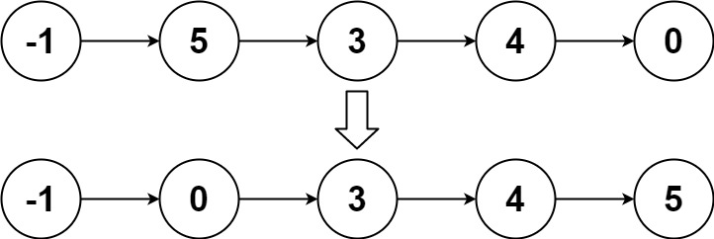

**Input:** head = [-1,5,3,4,0]

**Output:** [-1,0,3,4,5]

**Example 3:**

**Input:** head = []

**Output:** []

**Constraints:**

* The number of nodes in the list is in the range [0, 5 * 104].
* -105 <= Node.val <= 105

**Follow up:** Can you sort the linked list in O(n logn) time and O(1) memory (i.e. constant space)?